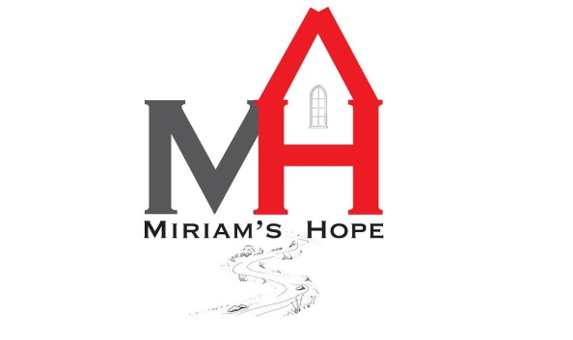
KEYSTONE PARTNERS
Miriam’s Hope considers it a great honor to partner with individuals and groups who are interested in supporting God’s work through His body. We do not look at those who support us as simply “donors”, but rather, actual partners in God’s great work. We have a mighty vision to literally change the culture of foster care, not just in Nebraska, but in the United States. So when you partner with us we become united in this great work.
Our focus, through our Keystone Partners, is to establish a core of committed partners who commit to giving on a consistent basis so we can continue to plan for long term vision which includes major expansion and replication of the ministry.
We are asking you to pray about becoming a Keystone Partner. In order to become a Keystone Partner we are asking that you commit to giving $1,000 a year for 5 years.
By becoming a Keystone Partner you will be invited to an annual brunch celebration of our ministry. You will be notified of the date and location as we would like to show our appreciation of your support!
Name:_______________________________________________________
Address:______________________________________City:______________State:______Zip:________
Phone:_________________
I commit to partnering with Miriam’s Hope by becoming a Keystone Partner. I will be giving:
Monthly:___
Quarterly:___
Annually:___
Thank You for your partnership! You may send this commitment card back to:
Miriam’s Hope, 1818 West B Street Hastings, NE 68901

